**Cholesky Identification Description**

**Variables:**

1. **GDP growth**: Responds slowly, influenced by its own past values (lags) and the lags of control variables.
2. **Gini_net changes**: Responds slowly, influenced by its own past values (lags), the lags of GDP growth, and the lags of control variables.
3. **Fiscal policy variables**: Responds contemporaneously, influenced by the current values of GDP growth and Gini_net changes, as well as its own lags and the lags of control variables.

**Ordering of Variables:**

1. GDP growth
2. Gini_net changes
3. Fiscal policy variables

**Cholesky Identification Matrix:** Given the ordering of variables, the matrix structure will be:

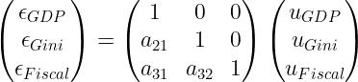

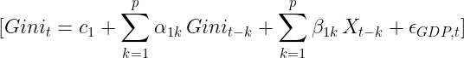

Where X represents the control variables and p is the lag order.

Contemporaneous Response:

* GDP growth and Gini_net changes only respond to their own contemporaneous shocks.
* Fiscal policy variables can respond to contemporaneous shocks in GDP growth and Gini_net changes.